Paddle Boat Canopy Package Assembly
Required Materials:
- Regular Flat Head Screwdriver
- Tape Measure
- Canopy Package Complete
***DO NOT OVER TIGHTEN THE SET SCREWS!
- Lay out the canopy top so that the inside is facing up (tags are on the inside and at the rear).
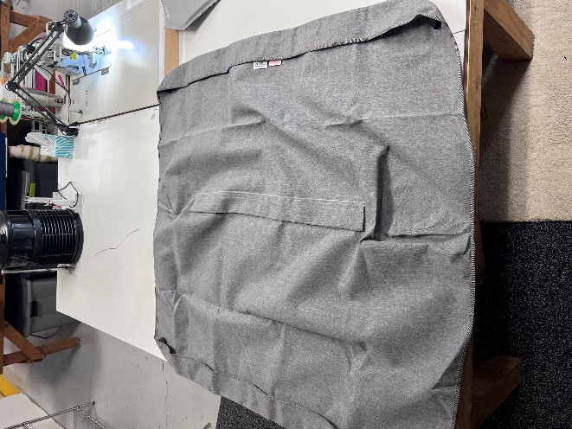
- Insert the short bow into the middle rod pocket.
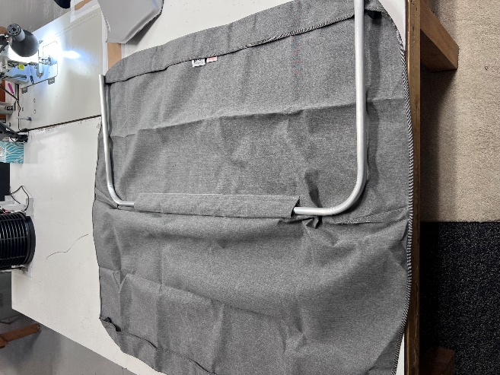
- Place the black canopy strap in the center of the cut out of the outside rod pockets with the rough sew seam facing up.
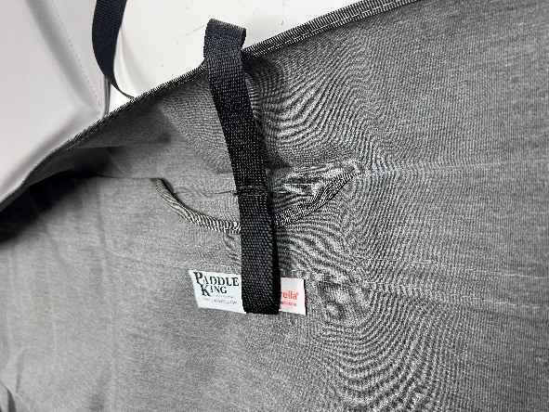
- Insert a long bow into each outside rod pocket and loose canopy straps.
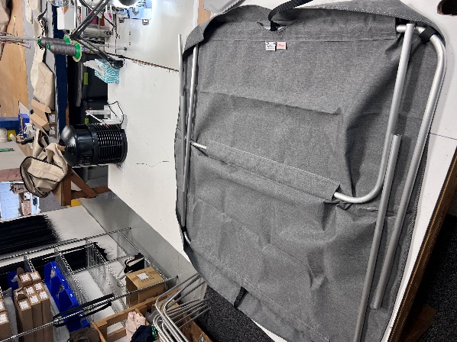
- Fasten the Velcro around the bows at each corner of the canopy.
- Place 3 frame joints on the rear bow in this order making sure that all set screws are facing toward you: 1 facing front, 1 facing rear, 1 facing front.
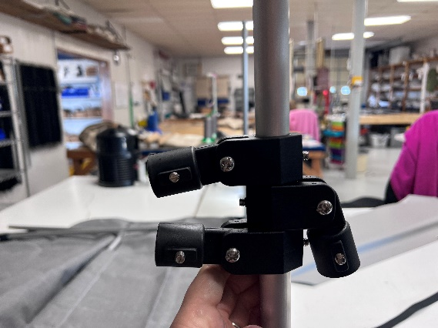
- Place one eye end completely on the bow with the set screw facing out and the tab perpendicular to the canopy bow.
- Tighten the set screw on the eye end until snug.
- Slide the top frame joint up snug to the eye end.
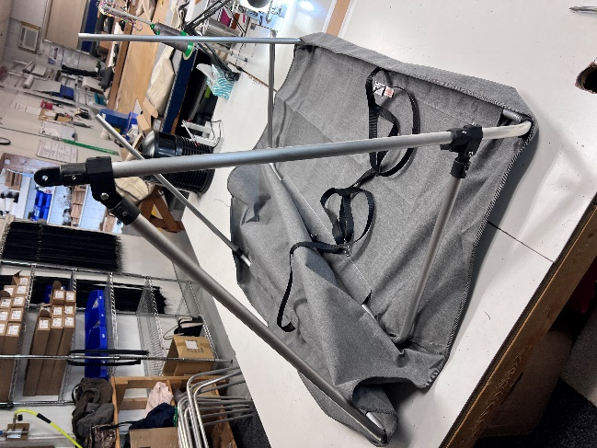
- With the set screw facing outward, make sure the joint is perpendicular to the canopy bow, then tighten the set screw until snug.
- With a tape measure, measure 17” from the end of the canopy bow to the middle of the bottom joint, making sure that the joint is perpendicular to the canopy bow.
- Tighten the set screw until snug.
- With a tape measure, measure 12” (PK3000) or 14.0625” (PK4400) from the end to the middle of second joint, making sure that the joint is perpendicular to the canopy bow.
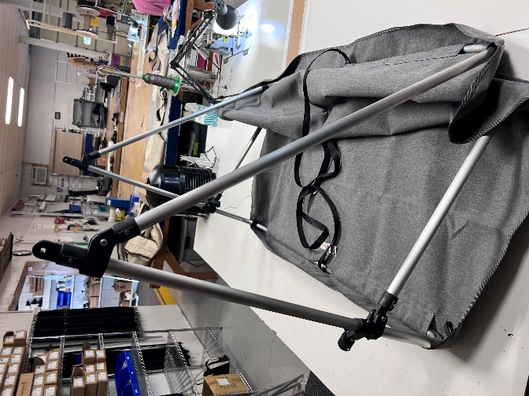
- Tighten the set screw until snug.
- Repeat steps 6-12 on the other side of the same rear canopy bow.
- Insert the other long bow and short bow into the eye ends of the two joints facing forward.
- Tighten all set screws on eye ends until snug.

